Google Chrome Instructions for Downloading the Health Train

Step 1: Click on the picture of the Health Train for the download to begin. You will see this box appear in the bottom corner of your screen.
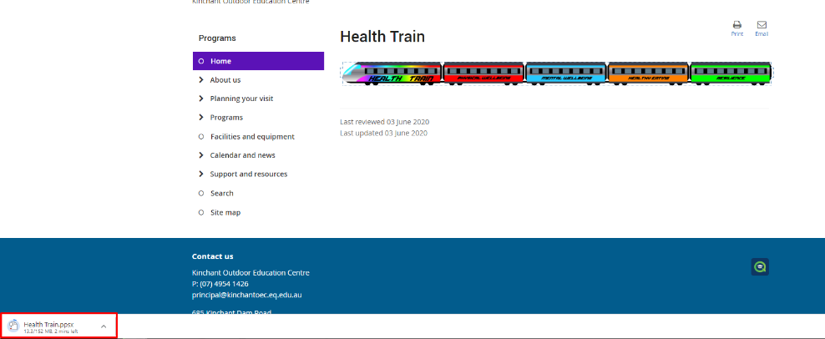

Once your download has completed click the little arrow on the right hand side of the download box and select Show in Folder.
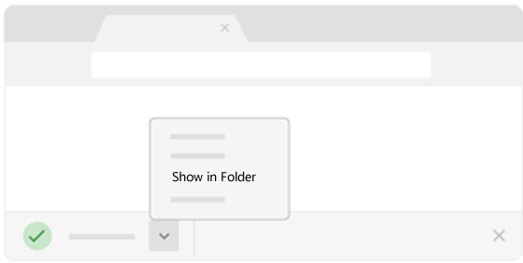
This will open your download folder.

Step 2: This will allow you to save the Health Train on your computer to prevent you from having to download it again next time you wish to use it.
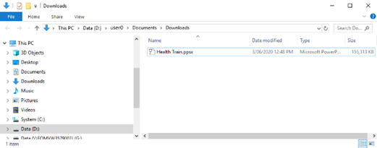

Copy the Health Train file from your downloads folder and paste it wherever you would like it stored.

Step 3: Once saved in a location of your choice, double click the Health Train file to open it.
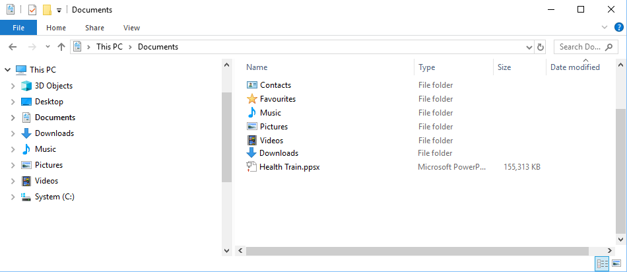

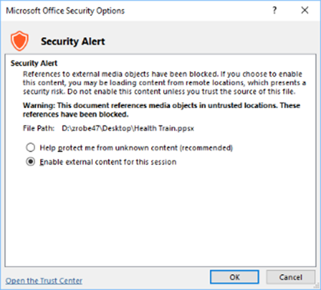
Step 4: You might get this security alert. Click on enable external content for this session and then click ok.

Step 5: Enjoy the Health Train

